**Devops Roles And Responsibilities**

**DevOps Engineer:**

Responsible for the gap between development, operations. They focus on automating processes, implementing CI/CD pipelines, managing configuration management tools, and ensuring smooth deployments.

Technologies Used:

* Docker
* Kubernetes
* Puppet
* Aws/azure
* Terraform

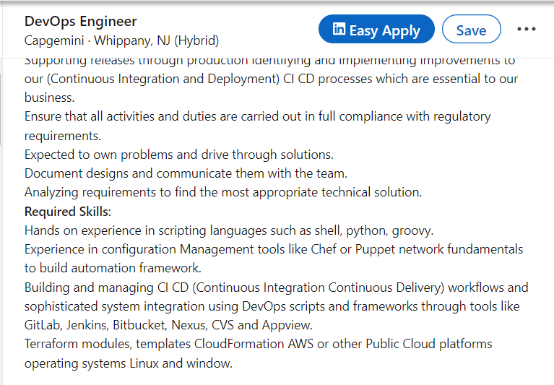

**Site Reliability Engineer (SRE):**

A specialized role within DevOps focused on maintaining reliability and scalability of systems. SREs use software engineering principles to design, build, and maintain large-scale distributed systems with a focus on automation, monitoring, and incident response.

Technologies Used:

* AWS
* MongoDB
* Core Java
* Elasticsearch

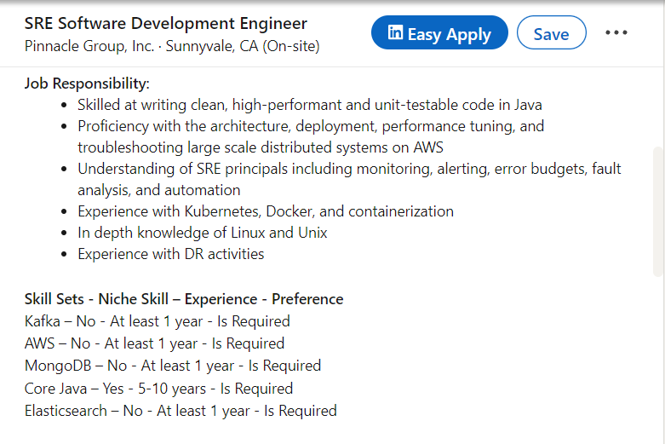

**Devops manager:**

Manages the release process and coordinates between development and operations teams to ensure timely and smooth releases. They are responsible for planning, scheduling, and controlling software releases, as well as communicating release status and managing risks.

Technologies Used:

* Git
* Jenkins
* Nexus
* Docker registry
* kubernetes

